------------------------------------------------------------------------------------------------------------------------------------------------
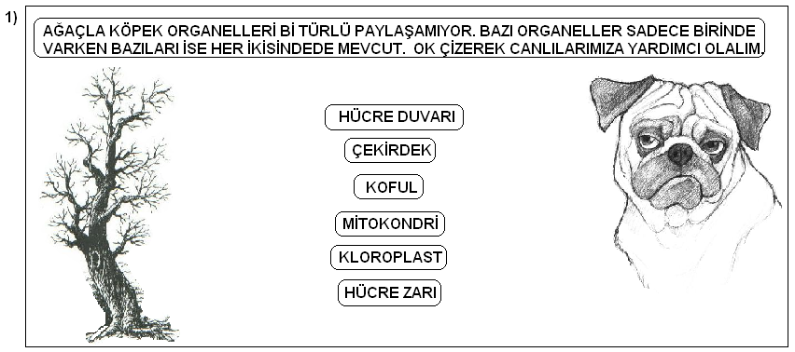

------------------------------------------------------------------------------------------------------------------------------------------------
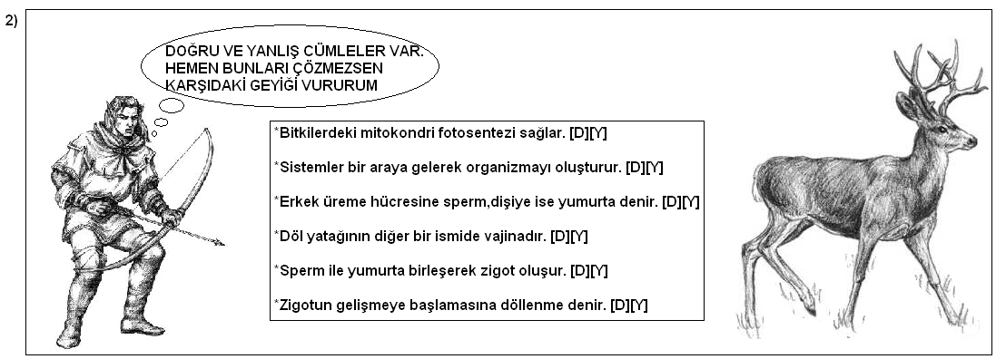
------------------------------------------------------------------------------------------------------------------------------------------------
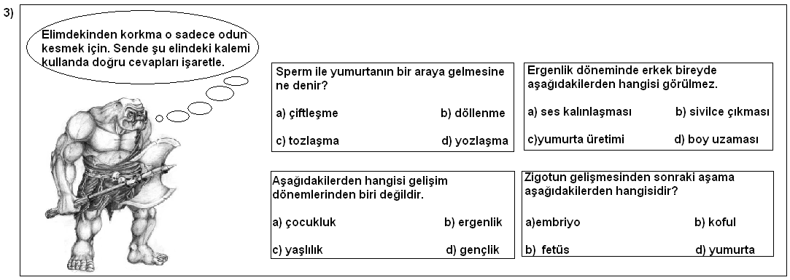
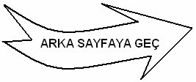
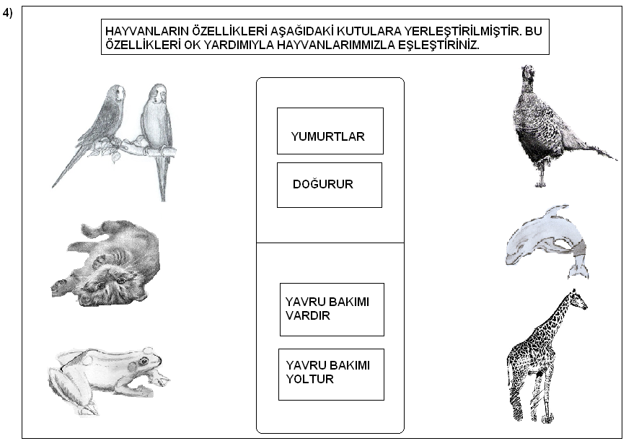
----------------------------------------------------------------------------------------------------------------------------------------------
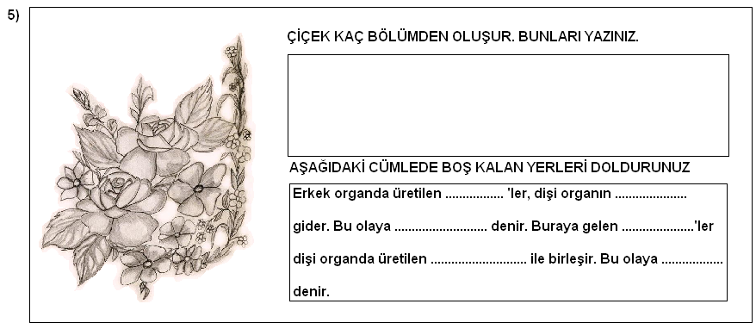
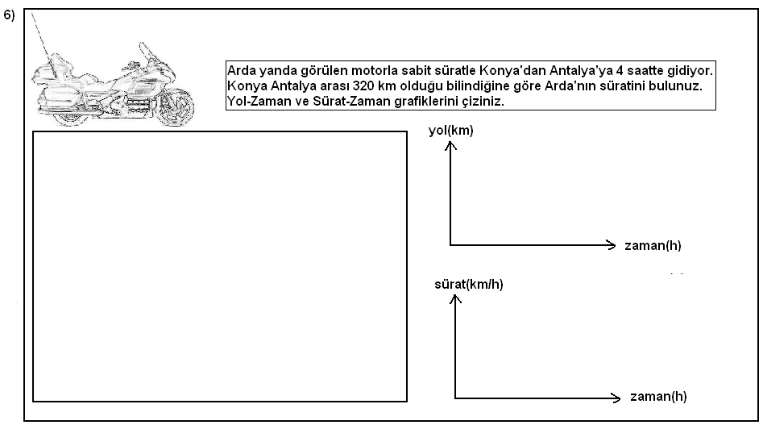
------------------------------------------------------------------------------------------------------------------------------------------------
------------------------------------------------------------------------------------------------------------------------------------------------
NOT: 5. VE 6. SORULAR 20’ŞER PUAN GERİ KALAN SORULAR 15’ER PUAN’DIR
------------------------------------------------------------------------------------------------------------------------------------------------


