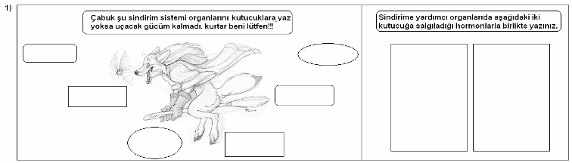
------------------------------------------------------------------------------------------------------------------------------------------------
------------------------------------------------------------------------------------------------------------------------------------------------
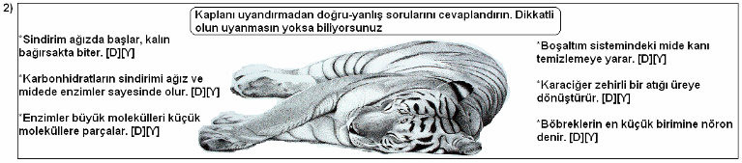
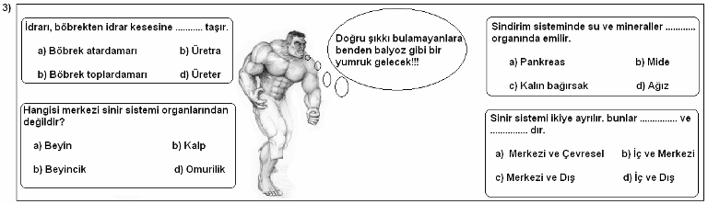
------------------------------------------------------------------------------------------------------------------------------------------------
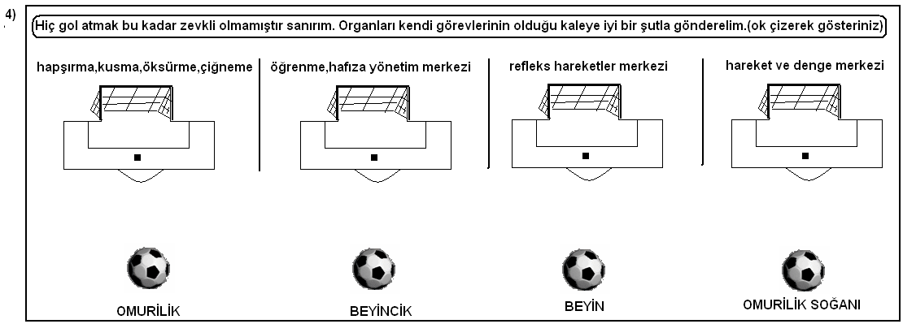
------------------------------------------------------------------------------------------------------------------------------------------------
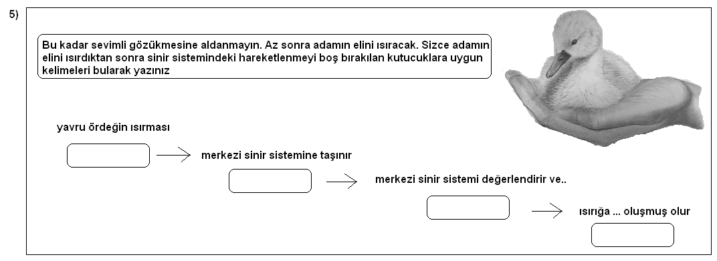
------------------------------------------------------------------------------------------------------------------------------------------------
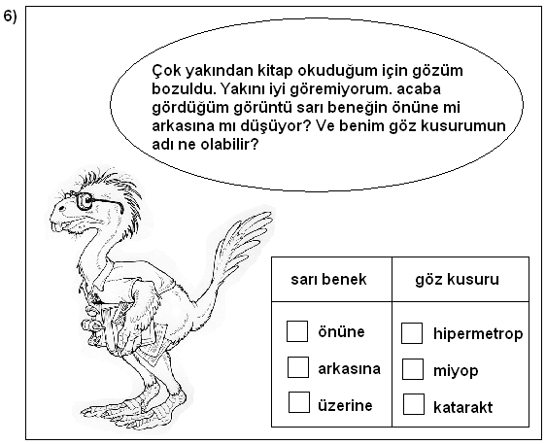
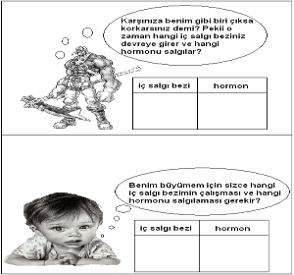

------------------------------------------------------------------------------------------------------------------------------------------------

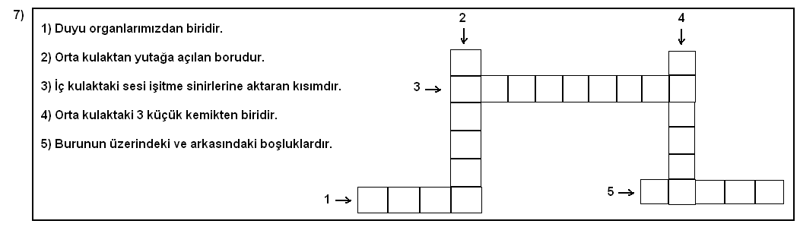
------------------------------------------------------------------------------------------------------------------------------------------------
NOT: 7. SORU 16 PUAN , GERİ KALAN SORULAR 14’ER PUANDIR.
------------------------------------------------------------------------------------------------------------------------------------------------



