------------------------------------------------------------------------------------------------------------------------------------------------
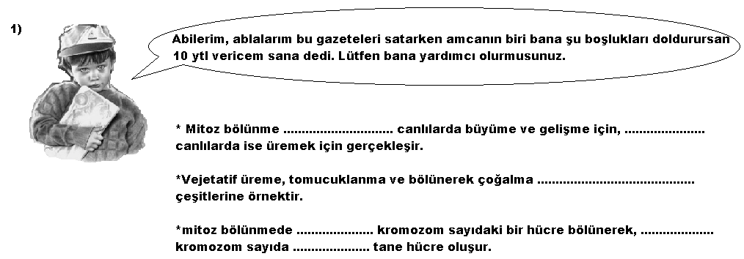

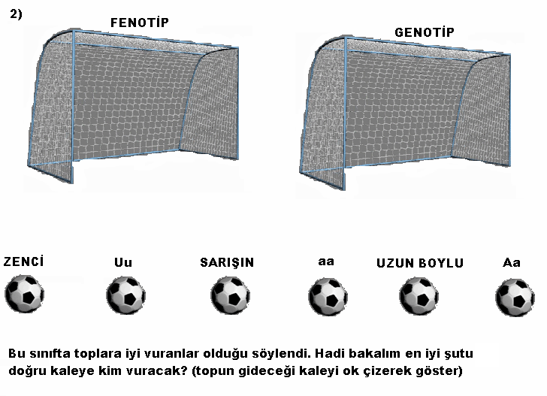
------------------------------------------------------------------------------------------------------------------------------------------------

------------------------------------------------------------------------------------------------------------------------------------------------

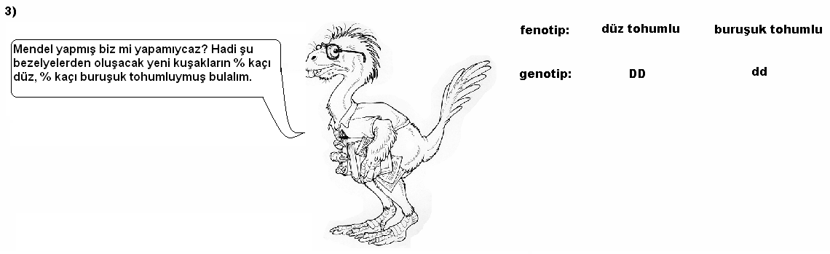
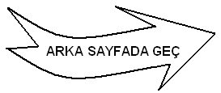

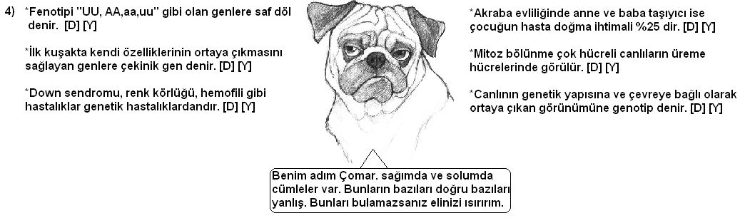
------------------------------------------------------------------------------------------------------------------------------------------------
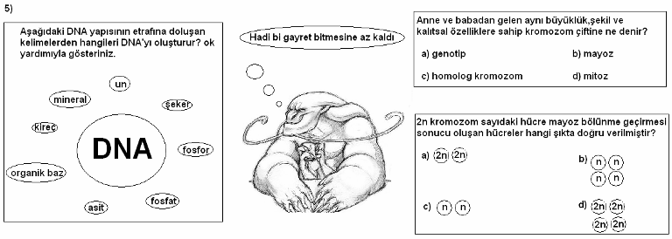
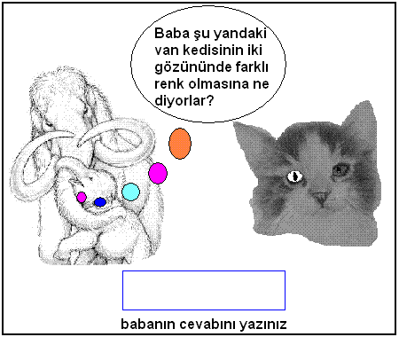
------------------------------------------------------------------------------------------------------------------------------------------------
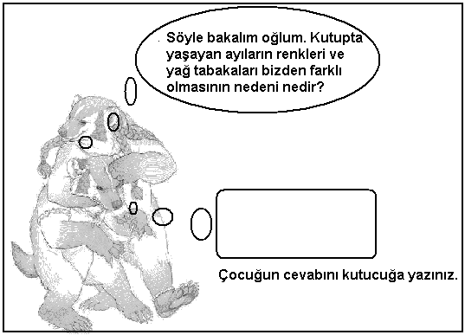

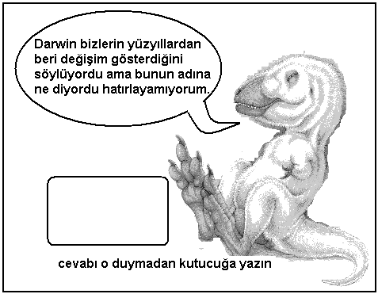
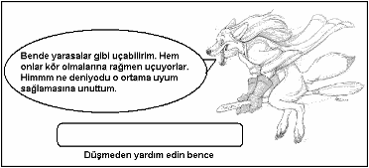

------------------------------------------------------------------------------------------------------------------------------------------------
NOT : 3. SORU 20 PUAN, GERİ KALAN SORULAR İSE 16’ŞAR PUANDIR.
------------------------------------------------------------------------------------------------------------------------------------------------



