GRUBUN ADI:……………………………………………………………..
ÖĞRENCİLERİN ADI:……………………………………………………….
ÖĞRENCİLERİN NUMARALARI:……………………………………….

GRUP TARTIŞMALARI
1.
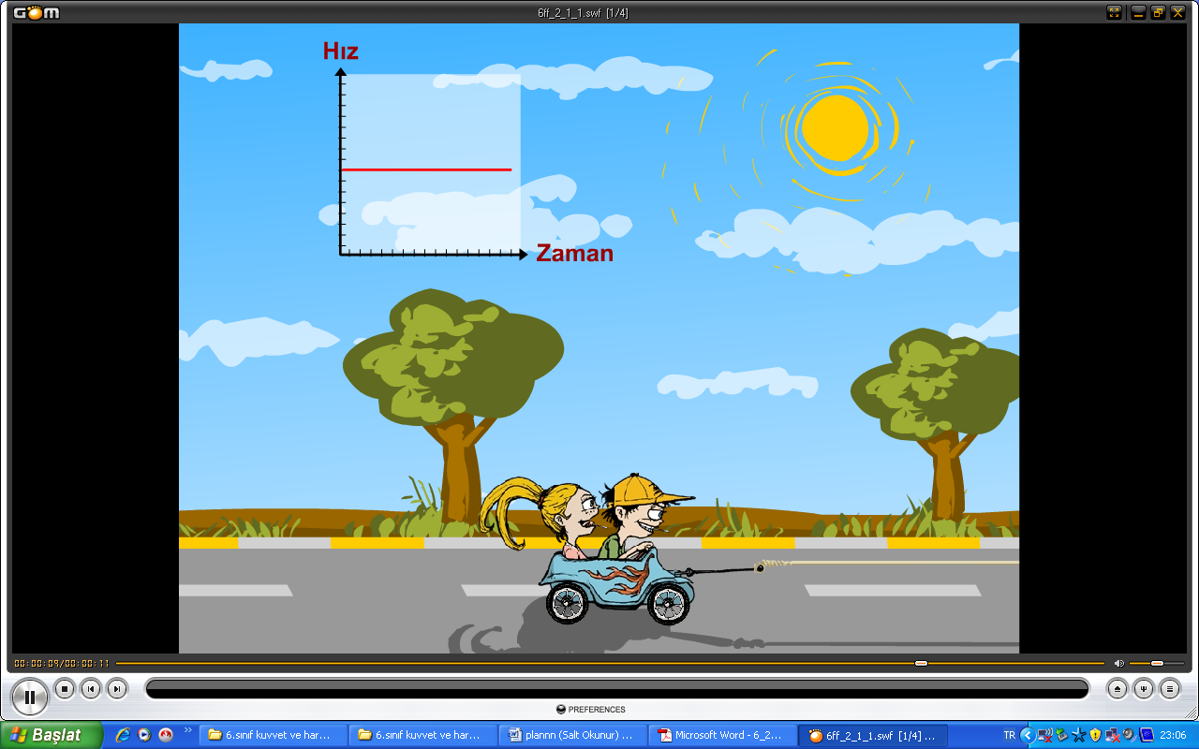
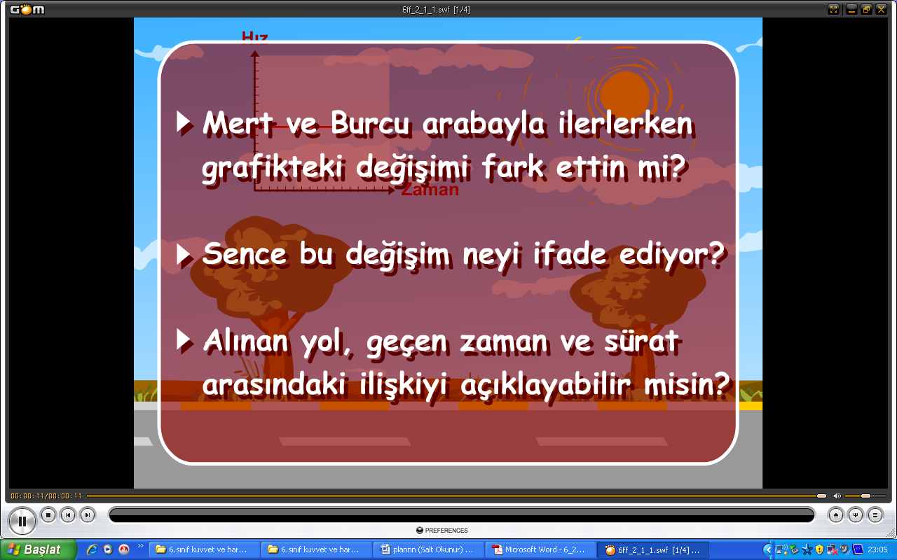

..................................................................................
..................................................................................
.................................................................................
2.
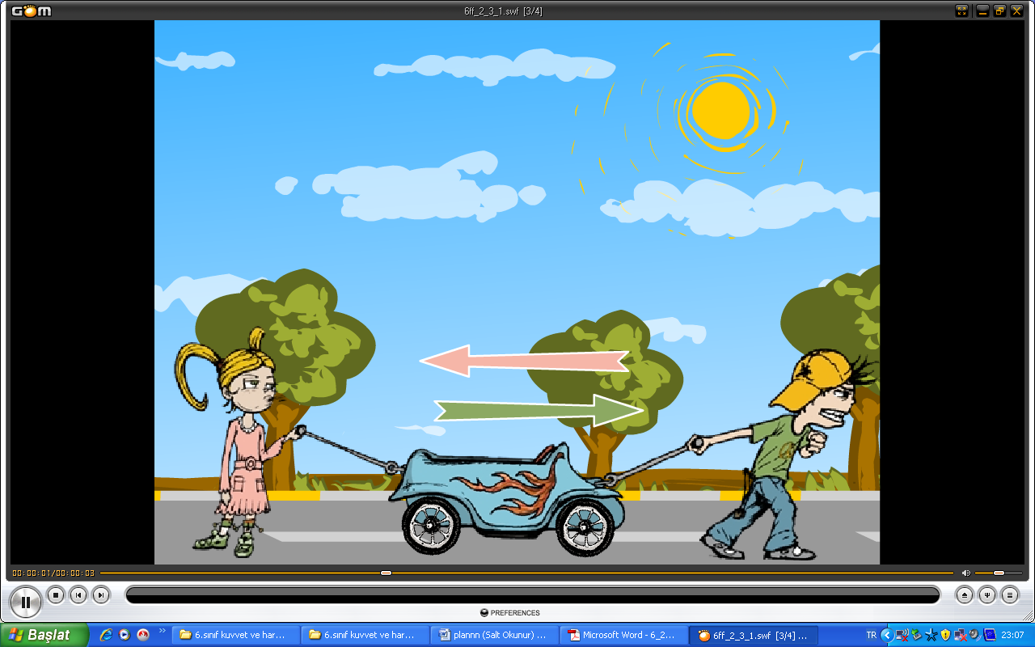
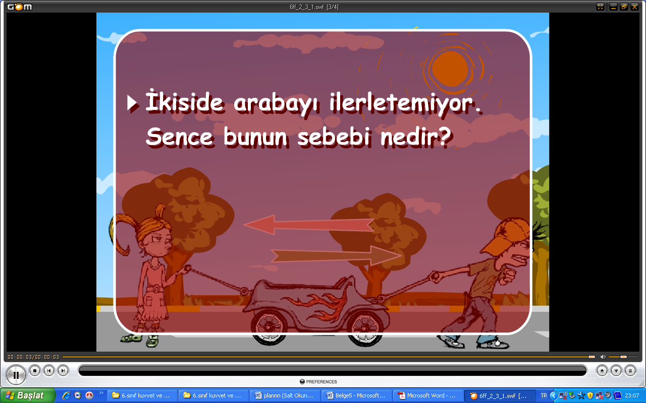
............................................................................

3.




